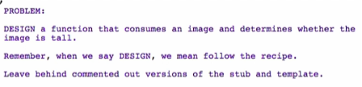

**Signature, Purpose, Stub**

Signature



Purpose



* When designing functions which produce a Boolean, you should be specific on what true means and what false will mean

Stub



* Functions that produce a Boolean, the function name must end in a “?”
  + Eg. func-name?

**Examples**





But how many tests does this function need? 🡪 go to the next part of the lecture